**Canvas-課程練習範本**

**課堂範例-基本矩形繪製**

<https://codepen.io/IreneHsiao/pen/GRRaNEb>

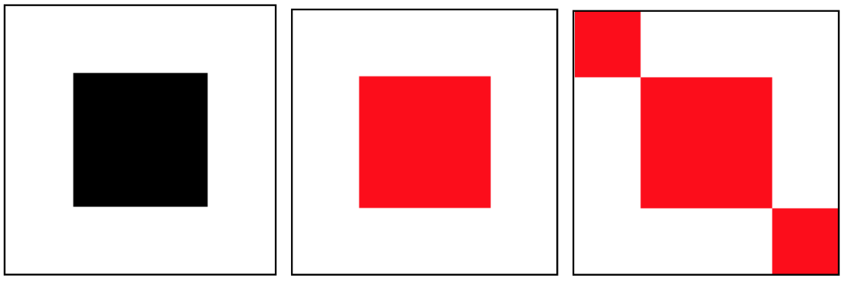

**課堂練習-矩形繪製：**[**https://codepen.io/IreneHsiao/pen/KKKLNgM**](https://codepen.io/IreneHsiao/pen/KKKLNgM)

